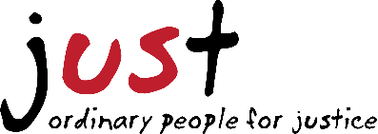
2020 Just Us for Justice VENDOR REGISTRATION FORM

Just Us for Justice welcomes vendors to either sell merchandise or promote a cause related to our mission to end modern day slavery.

*Application DUE DATE: Wednesday July 15, 2020
*Just Us for Justice 2020 will be held at Carson Park in Eau Claire, WI, on Wednesday July 22, 2020
*Setup will begin at 3:00 p.m., the event runs from 4:30-8:00 p.m., and cleanup will begin at 8:00 p.m.
*Vendors must provide their own equipment (tents, tables, chairs, etc.)
*No electricity or running water is available
*We do not charge a vendor fee. Vendors selling consumable goods are required to submit proof of insurance.
*Once your application has been reviewed, you will be notified whether you have been approved.

--------------------------------------------------------------------------------------------------------------------------------------------------
Please fill out the following application and submit it to: Fierce Freedom, Attn: Carrie Swartz, 2519 Hillcrest Pkwy. Ste. 200, Altoona WI 54720.

COMPANY NAME: __________________________________________________________________________

CONTACT PERSON: __________________________________________________________________________

ADDRESS: _________________________________________________________________________________

PHONE: ___________________________________________________________________________________

EMAIL: ___________________________________________________________________________________

Description of booth/items sold:

How does your booth relate to our mission to end modern day slavery?

Just Us for Justice is not responsible for lost/stolen/damaged merchandise or any injury incurred during the Just Us for Justice Event.

Vendor Signature: __________________________________________________________________________

Date: __________________________________

Please direct questions to Carrie Swartz at 715-864-5276 or carrie@fiercefreedom.org

